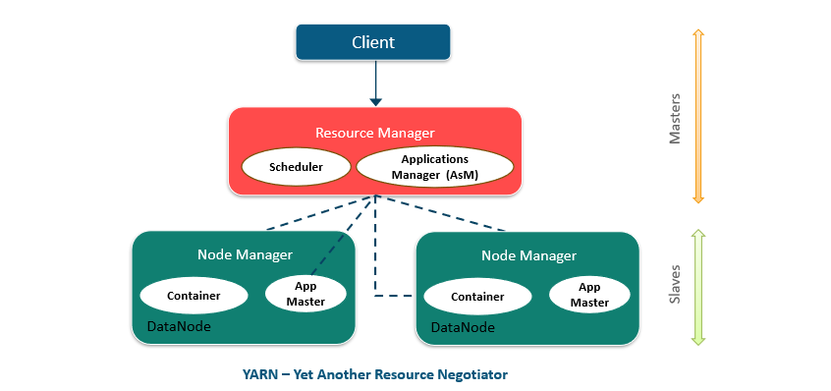

* The **ResourceManager** is the ultimate authority that arbitrates resources among all the applications in the system. It is responsible for allocating resources to the various running applications subject to familiar constraints of capacities, queues etc.

1. Scheduler：is pure scheduler in the sense that it performs no monitoring or tracking of status for the application. Also, it offers no guarantees about restarting failed tasks either due to application failure or hardware failures.
2. ApplicationsManager：is responsible for accepting job-submissions, negotiating the first container for executing the application specific ApplicationMaster and provides the service for restarting the ApplicationMaster container on failure.

* The **NodeManager** is the per-machine framework agent who is responsible for containers, monitoring their resource usage (cpu, memory, disk, network) and reporting the same to the ResourceManager/Scheduler. It is responsible for accepting job-submissions, negotiating the first container for executing the application specific ApplicationMaster and provides the service for restarting the ApplicationMaster container on failure.

1. ApplicationMaster：has the responsibility of negotiating appropriate resource containers from the Scheduler, tracking their status and monitoring for progress.
2. Container：which incorporates elements such as memory, cpu, disk, network etc.

* TimelineServer：Persisting Application Specific Information、Persisting Generic Information about Completed Applications

附：

|  |  |
| --- | --- |
| yarn.resourcemanager.scheduler.class | 调度器：FIFO/Capacity/Fair |
| yarn.scheduler.capacity.root.queues | 定义队列 |
|  |  |